Lab 5 :- Intermediate Programs Using Structure and Union
- Create structure student with name, percentage and age. Read data of 5 students using array of structure.

#include <stdio.h>

struct Student {
char name[50];
float percentage;
int age;
};

int main() {
struct Student students[5];

for (int i = 0; i < 5; i++) {
printf("Enter details for student %d:\n", i + 1);
printf("Name: ");
getchar();
gets(students[i].name);
printf("Percentage: ");
scanf("%f", &students[i].percentage);
printf("Age: ");
scanf("%d", &students[i].age);
}

printf("\nStudent Details:\n");
for (int i = 0; i < 5; i++) {
printf("Student %d:\n", i + 1);
printf("Name: %s\n", students[i].name);
printf("Percentage: %.2f\n", students[i].percentage);
printf("Age: %d\n", students[i].age);
printf("\n");
}

return 0;
}
Output:-
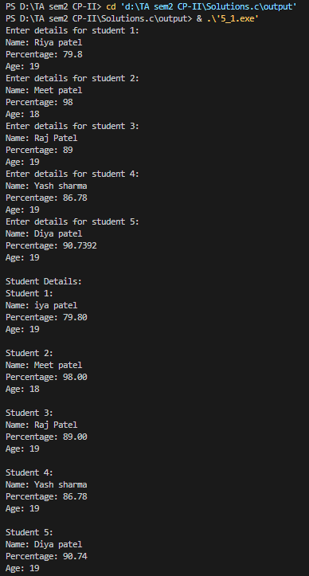

2. Create structure student with name, percentage and age. Read data of N students using array of structure. Print details of student with maximum percentage
#include <stdio.h>
#include <string.h>

struct Student {
char name[50];
float percentage;
int age;
};

int main() {
int n, maxIndex = 0;

printf("Enter the number of students: ");
scanf("%d", &n);

struct Student students[n];

for (int i = 0; i < n; i++) {
printf("Enter details for student %d:\n", i + 1);
printf("Name: ");
getchar();
gets(students[i].name);
printf("Percentage: ");
scanf("%f", &students[i].percentage);
printf("Age: ");
scanf("%d", &students[i].age);
}

for (int i = 1; i < n; i++) {
if (students[i].percentage > students[maxIndex].percentage) {
maxIndex = i;
}
}

printf("\nStudent with the highest percentage:\n");
printf("Name: %s\n", students[maxIndex].name);
printf("Percentage: %.2f\n", students[maxIndex].percentage);
printf("Age: %d\n", students[maxIndex].age);

return 0;
}

Output:-
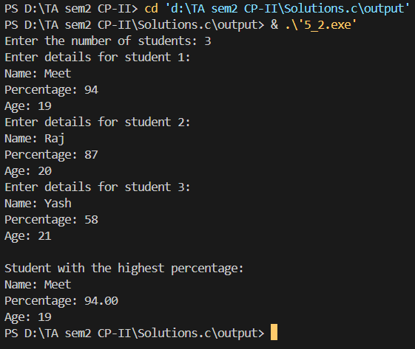

3.Create structure student with name, percentage and age. Read data of N students using array of structure. Arrange student data alphabetically and print all data
#include <stdio.h>
#include <string.h>

struct Student {
char name[50];
float percentage;
int age;
};

int main() {
int n;

printf("Enter the number of students: ");
scanf("%d", &n);
struct Student students[n], temp;
for (int i = 0; i < n; i++) {
printf("Enter details for student %d:\n", i + 1);
printf("Name: ");
getchar();
gets(students[i].name);
printf("Percentage: ");
scanf("%f", &students[i].percentage);
printf("Age: ");
scanf("%d", &students[i].age);
}
for (int i = 0; i < n - 1; i++) {
for (int j = i + 1; j < n; j++) {
if (strcmp(students[i].name, students[j].name) > 0) {
temp = students[i];
students[i] = students[j];
students[j] = temp;
}
}
}
printf("\nStudent details sorted alphabetically:\n");
for (int i = 0; i < n; i++) {
printf("Name: %s\n", students[i].name);
printf("Percentage: %.2f\n", students[i].percentage);
printf("Age: %d\n", students[i].age);
printf("\n");
}
return 0;
}

Output:-
